In triangle making program we had everything in the Main.cpp file

Here we will be organizing the various code in different files

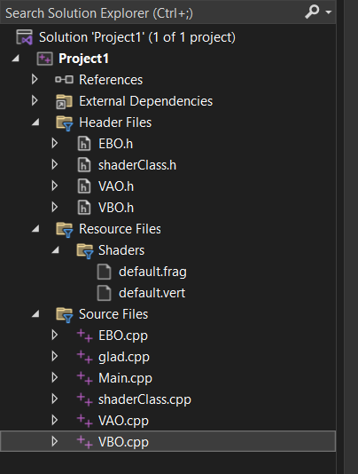

Here we create many files in different folders and organize our code in Main.cpp

This folder contains the Project1 folder which contains all the organized code for drawing the triangles